**SQL MURDER MYSTERY**

Submitted by Archana P, 2237027, 2MAECO

1. To know all the crimes that took place in SQL City on jan.15.2018.

SELECT *

FROM crime_scene_report

WHERE date = '20180115' and

city = 'SQL City'

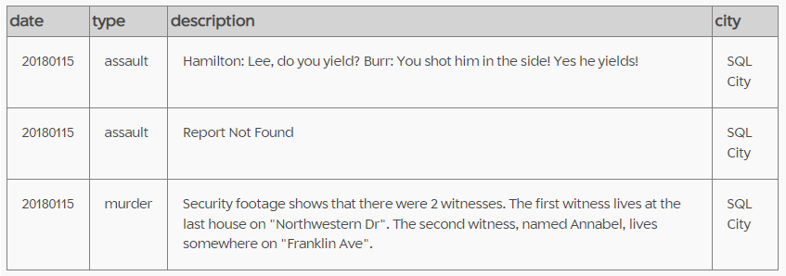

1. Obtaining details of second witness Annabel

SELECT *

FROM person

WHERE name

LIKE ‘Annabel%’

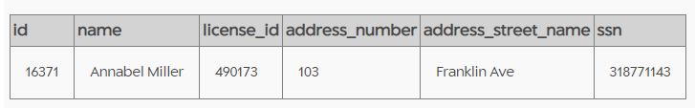

1. Finding name and other information on witness living in last house in Northwestern Dr

SELECT *

FROM person

WHERE address_street_name = 'Northwestern Dr'

ORDER BY address_number desc

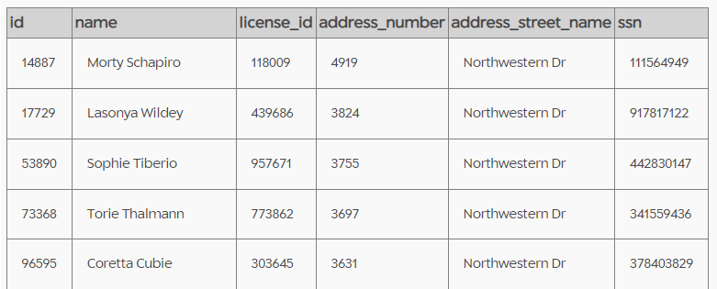

1. Retrieving interviews of both the witness

SELECT person_id,transcript

FROM interview

WHERE person_id = 14887

OR person_id = 16371

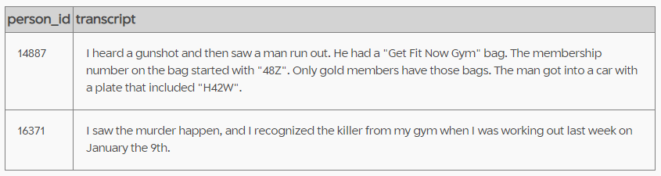

1. Checking for car details with plate number including HA2W

SELECT *

FROM drivers_license

WHERE plate_number

LIKE '%H42W%'

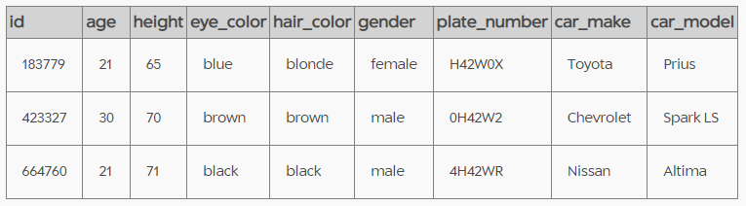

1. Details of the person mentioned by the witness, with membership number starting with 48Z who went to gym on January 9th 2018

SELECT *

FROM get_fit_now_check_in

JOIN get_fit_now_member

ON get_fit_now_check_in.membership_id = get_fit_now_member.id

WHERE membership_id

LIKE '48Z%'

AND check_in_date = 20180109

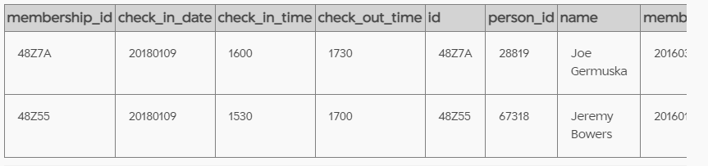

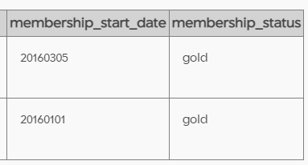

1. Checking the events that person id 67318 has attended

SELECT *

FROM facebook_event_checkin f

LEFT JOIN person p

ON f.person_id=p.id

WHERE person_id=67318

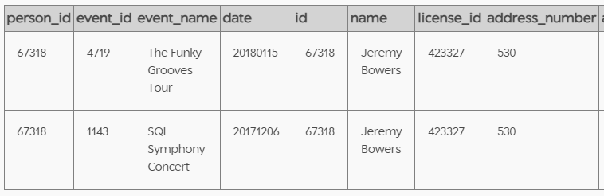

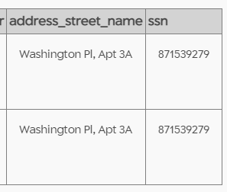

1. Getting personal details of the person with license id 423327

SELECT *

FROM person p

LEFT JOIN drivers_license d

ON p.license_id=d.id

WHERE license_id=423327

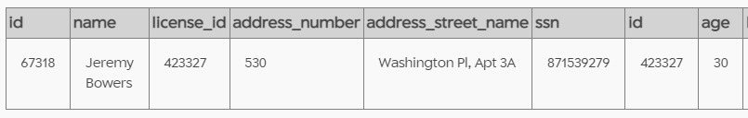

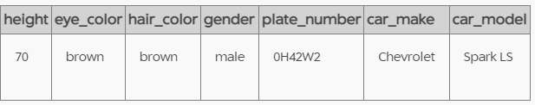

Checking the solution

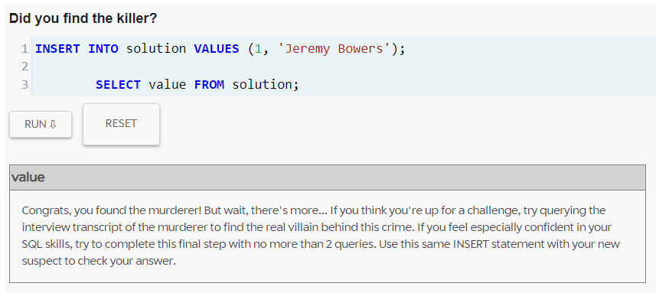

Retrieving the statement of Jeremy Bowers

SELECT *

FROM interview

WHERE person_id= '67318'

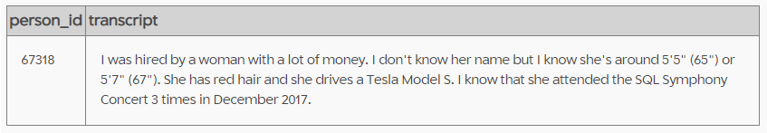

1. Finding the female with red hair, around 65 or 67 and drives Tesla Model

SELECT*

FROM person p

INNER join drivers_license as d

ON d. id= p.license_id

INNER JOIN income as i

ON i.ssn = p.ssn

WHERE d.gender = "female"

AND d.car_make = "Tesla"

AND d.car_model = "Model S"

AND d.height > 65

AND d.height < 67

AND d.hair_color = "red"

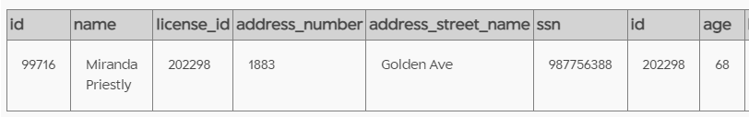

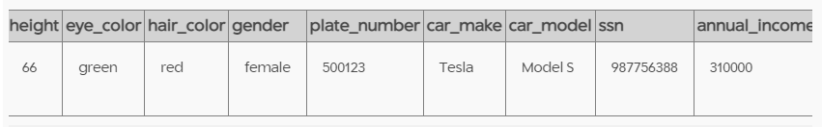

1. Obtaining information on the events that Miranda Priestly, id number 99716 attended

SELECT *

FROM facebook_event_checkin f

LEFT JOIN person p

ON f.person_id=p.id

WHERE person_id= 99716

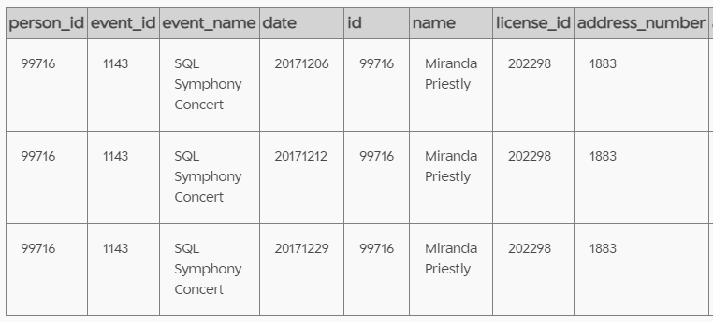

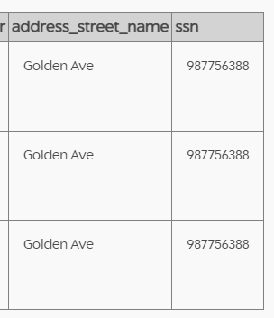

Checking the solution

